
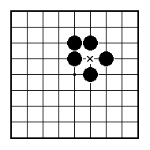
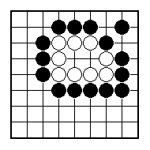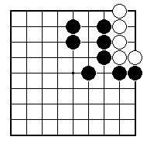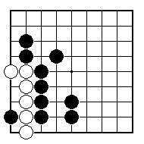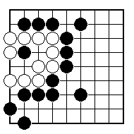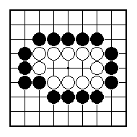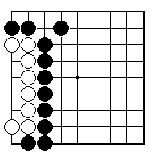
Can the white group make two eyes?

How can the white group make two eyes?

How can the white group make two eyes?
How can the white group make two eyes?

How can Black stop White from making two eyes?

Can Black stop White from making two eyes?

NAME:
BRITISH GO ASSOCIATION CERTIFICATE LEVEL 1 - SHEET 10

ONE BIG EYE

